<https://pixabay.com/photos/student-school-learn-education-411947/>

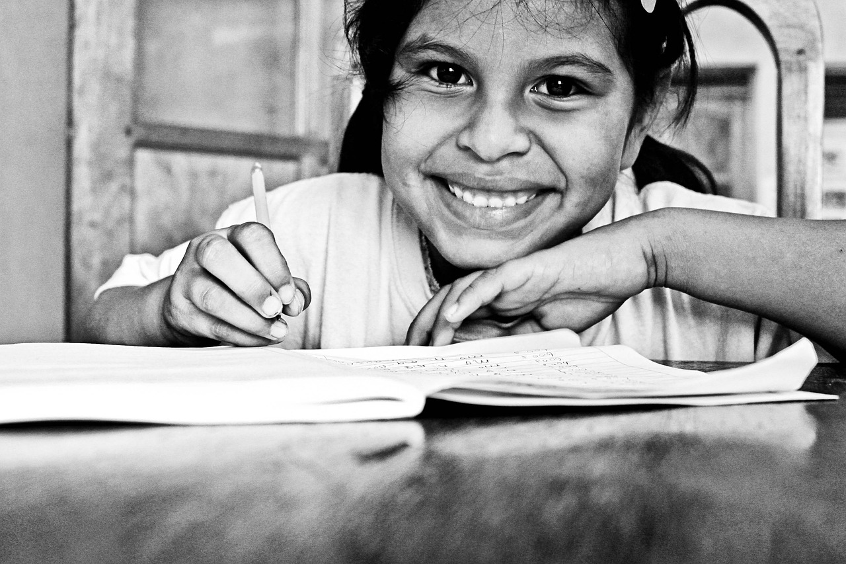

[**PremierCompanies**](https://pixabay.com/users/premiercompanies-372586/)19 followers  
Free for use under the Pixabay [**Content License**](https://pixabay.com/service/license-summary/)

<https://pixabay.com/photos/boy-book-reading-literature-read-5731001/>

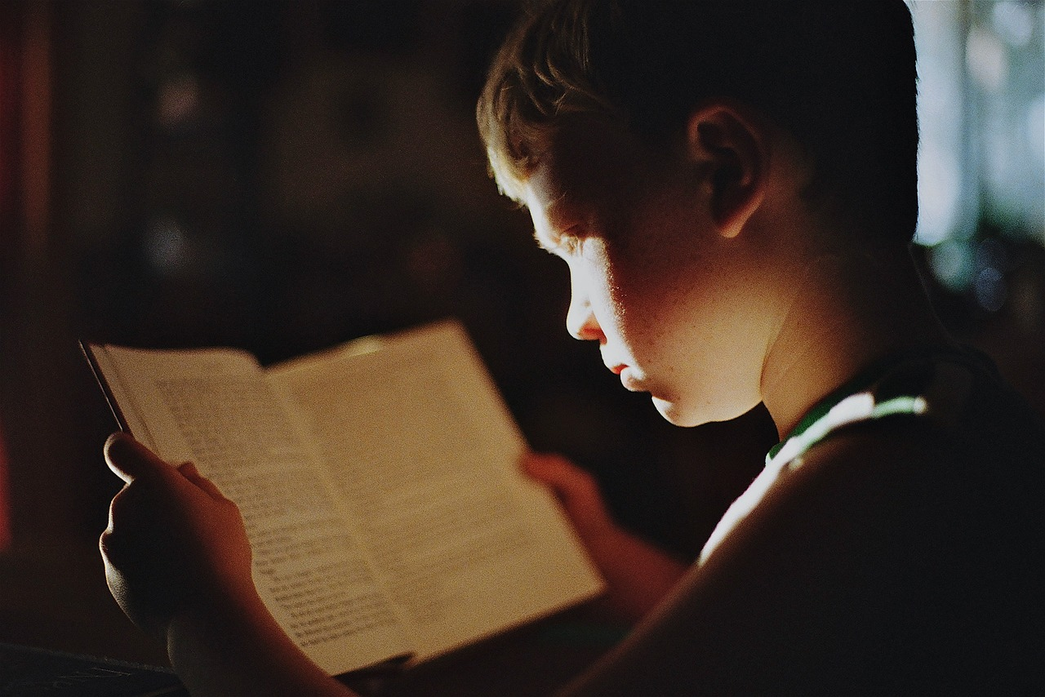

[](https://pixabay.com/users/nwimagesbysabrinaeickhoff-13202465/)

[**NWimagesbySabrinaEickhoff**](https://pixabay.com/users/nwimagesbysabrinaeickhoff-13202465/)200 followers

Free for use under the Pixabay [**Content License**](https://pixabay.com/service/license-summary/)

https://pixabay.com/photos/old-lady-woman-old-female-elderly-417174/

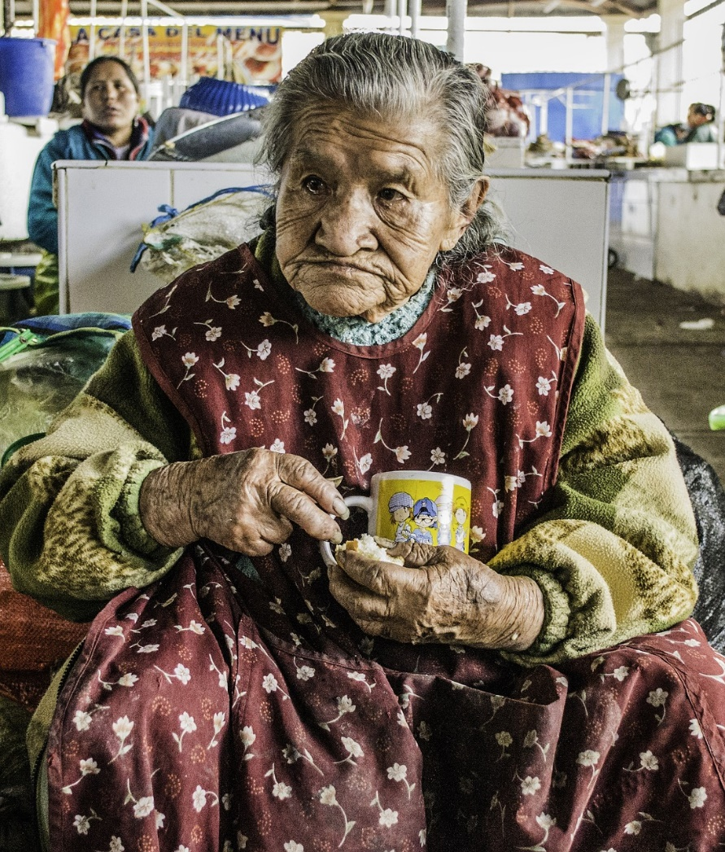

[](https://pixabay.com/users/benralexander-382048/)

[**benralexander**](https://pixabay.com/users/benralexander-382048/)43 followers  
Free for use under the Pixabay [**Content License**](https://pixabay.com/service/license-summary/)

<https://pixabay.com/photos/people-homeless-woman-street-850949/>

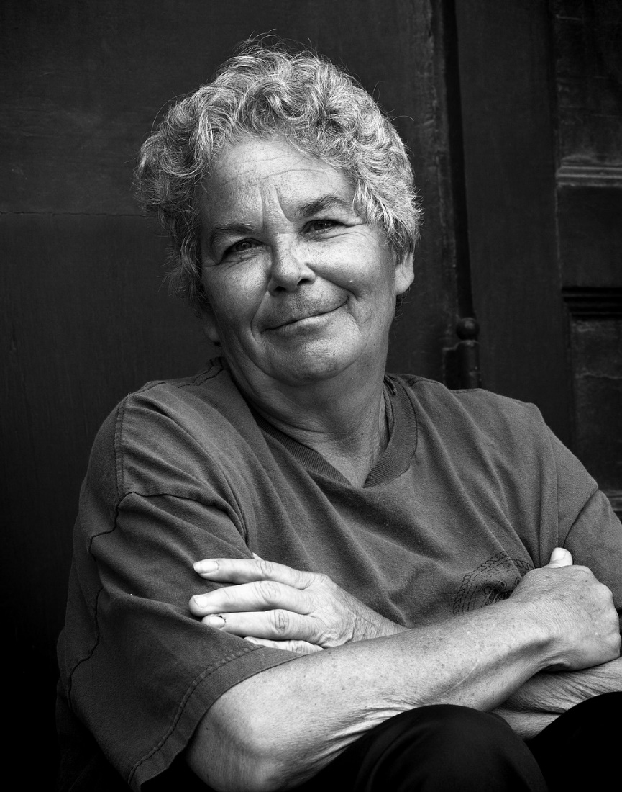

[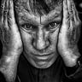](https://pixabay.com/users/leroy_skalstad-1202818/)

[**Leroy_Skalstad**](https://pixabay.com/users/leroy_skalstad-1202818/)1,638 followers

Free for use under the Pixabay [**Content License**](https://pixabay.com/service/license-summary/)

<https://pixabay.com/photos/hospital-sick-doctor-disease-4885848/>

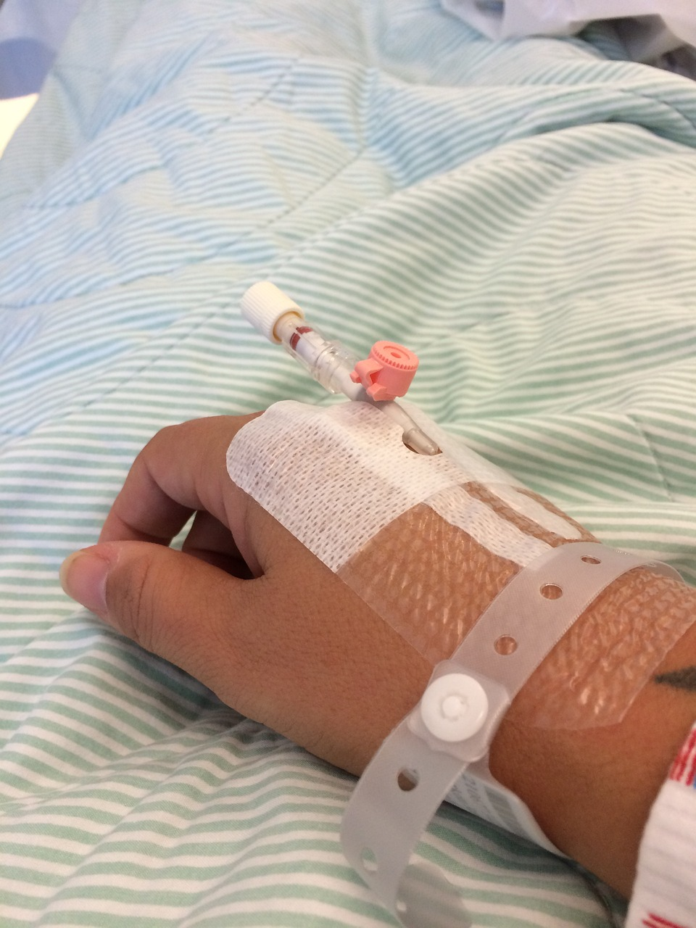

[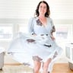](https://pixabay.com/users/artbyrm-10131215/)

[**ArtByRM**](https://pixabay.com/users/artbyrm-10131215/)5 followers

Free for use under the Pixabay [**Content License**](https://pixabay.com/service/license-summary/)



[](https://pixabay.com/users/sasint-3639875/)

[**sasint**](https://pixabay.com/users/sasint-3639875/)16,961 followers

Free for use under the Pixabay [**Content License**](https://pixabay.com/service/license-summary/)